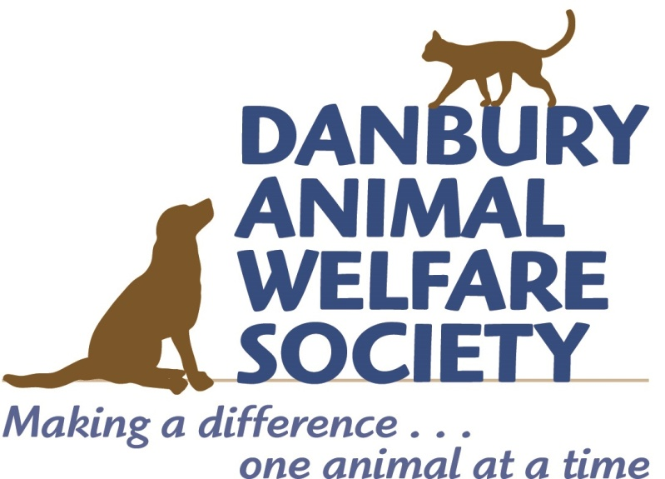
PAWS FOR CELEBRATION SPONSORSHIP OPTIONS
Thank you for your interest in being a Ball sponsor! Each year our generous sponsors help DAWS raise funds to save the lives of animals in need. This year's sponsorship opportunities are:

TITLE SPONSOR: $5,000
Event signage and recognition, featured in publicity, back cover journal ad, 2 tables of 10

TOP RESCUER: $3,500
Event signage and recognition, featured in publicity, inside front cover journal ad, 2 tables of 10

HEART OF GOLD COCKTAIL SPONSOR: $2,000
Event signage and recognition, featured in publicity, inside back cover journal ad, 1 table of 10

WHISKERS AND PUPPY BREATH SPONSOR: $1,500
Event signage and recognition, 1/2 page journal ad, 1 table of 10

FOREVER HOME EVENT SPONSOR: $1,000
Event signage and recognition, full page journal ad, 4 guest tickets

To be a Ball sponsor, please contact Stephanie Barksdale at stephanie.barksdale@daws.org or at 203-744-3297 with your name, the name of the organization, and the sponsorship you are interested in.

For sponsorship journal advertisements, please send your artwork file as a high resolution PDF or JPG at actual size to stephanie.barksdale@daws.org by August 15, 2019.

From all of us at DAWS, thank you!

