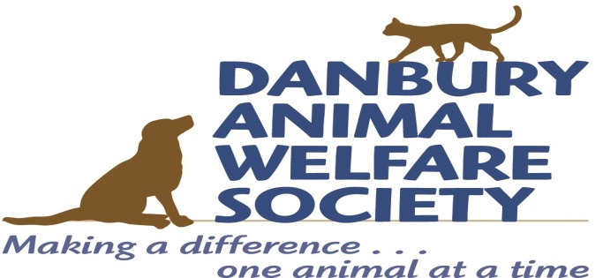
2019 BALL
AUCTION ITEM DONATION FORM
Please print, complete, and mail to Denise Musser at the address below. Thank you!
____________________________________________________________________________
Name Company

____________________________________________________________________________
Address

____________________________________________________________________________
City State Zip

____________________________________________________________________________
Phone Email

Item Information:

___________________________________________________________________________ Auction item

S_______________________________________$__________________________________
Approximate Value (estimated by donor) Suggested Minimum Bid

Item Description: (Please include any restrictions)
___________________________________________________________________________
___________________________________________________________________________
___________________________________________________________________________

Is the item/gift certificate enclosed? Yes No Please enclose small items (e.g., tickets or gift certificates) with this form and mail to Denise Musser at the address below by August 15th

Will the item be delivered? Yes No Please deliver large items to Denise Musser at the address below by August 15th. For questions or to coordinate delivery or pick-up, please contact Stephanie Barksdale at 203-744-3297 or stephanie.barksdale@daws.org

Mail or deliver donated items to: DAWS 2019 Ball, ATTN: Denise Musser, 147 Grassy Plain Street, Bethel, CT 06801

Your gift provides support for Danbury Animal Welfare Society, a 501(c)3 non-profit organization, Federal Tax ID #06-0945388, and is tax deductible to the extent allowed by law. For help in valuing your donation, refer to IRS Publication 561, or consult your tax advisor. Please retain this receipt for your tax records.

